Synopsis

AI-Driven Agricultural Region Segmentation Using K-Means Clustering

Problem Id: AIML-4

Student Name: Kartikeya Arya
University Roll number: 2028443
Section: Q

Student Name: Aayush Rawat
University Roll number: 2028608
Section: Q

Student Name: Aashish Singh
University Roll number: 2028606
Section: Q

- Problem Description:
This project aims to design an analytical machine learning system that groups agricultural regions based on 20 distinct environmental factors and crop yield characteristics. Utilizing a structured dataset containing metrics like average rainfall, soil pH, fertilizer usage, and historical crop yield, the system will apply the unsupervised K-Means clustering algorithm to identify hidden patterns and similarities among different regions.

- Steps of Implementation:
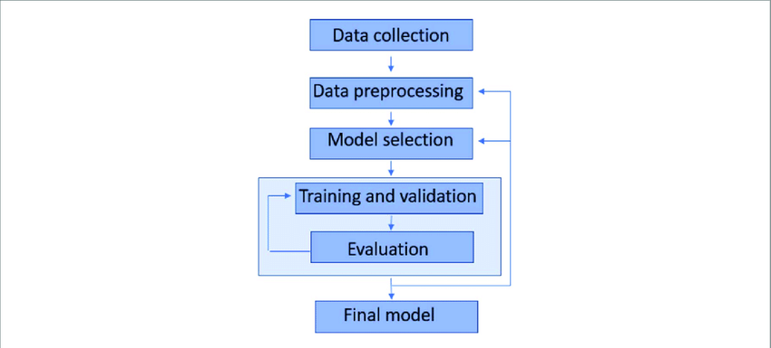
• Phase 1: Data Collection: Procuring or synthetically generating a structured dataset containing the exact 20 region-level features required by the problem statement.
• Phase 2: Exploratory Data Analysis (EDA): Analyzing the dataset to understand feature distributions and mapping correlations across different regions using heatmaps.
• Phase 3: Data Preprocessing: Cleaning the data by handling missing values (via imputation) and applying normalization (e.g., StandardScaler) so all variables are on comparable scales.
• Phase 4: Feature Selection: Utilizing Forward or Backward Feature Elimination (using crop yield as a proxy target) to identify the most crucial features for meaningful clustering.
• Phase 5: Pre-Clustering Visualization: Using dimensionality reduction (like PCA) to plot the high-dimensional processed data into an interpretable 2D feature space.
• Phase 6: Model Selection & Training: Determining the optimal number of clusters (K) using the Elbow Method, and then applying the K-Means algorithm to group the regions.
• Phase 7: Evaluation & Prediction: Interpreting the clusters visually, evaluating model accuracy using the Silhouette Score, and successfully predicting the cluster label for newly inputted, unseen regional data points.

- Expected Modules/ Libraries to be used :
- Pandas: Used for robust data manipulation, handling missing values, and structuring the dataset as a DataFrame.
- NumPy: Essential for mathematical computations, array operations, and generating synthetic regional data if needed.
- Matplotlib: A core graphical library utilized for basic visualizations like histograms and plotting the Elbow Method line curve.
- Seaborn: Used for generating highly attractive statistical graphics, specifically the correlation heatmaps during the EDA phase.
- Scikit-learn (sklearn): The primary machine learning module used for Standard Scaling, K-Means clustering, Feature Selection, and calculating the Silhouette Score.

- Expected Evaluation metrics and Plots to be used:
Evaluation Metrics:
- Silhouette Score: We will use this to evaluate how well-separated and distinct our generated agricultural clusters are. A score closer to 1 will indicate highly effective clustering.
- WCSS (Within-Cluster Sum of Squares): This mathematical metric will be calculated to measure the variance within clusters to help determine the optimal 'K'.
Plots:
- Correlation Heatmap: Used during EDA to visually verify which environmental factors (like rainfall and soil moisture) are highly related.
- Elbow Curve: A line plot of WCSS against the number of clusters (K) to visually spot the "elbow" point, proving we selected the optimal number of groups.
- PCA Scatter Plots: Used post-clustering to project our 20-feature dataset onto a 2D graph so we can visually interpret the separated agricultural groups.

- Required topics from the subject:
• Data Structures (Lists, Dictionaries, Arrays): Essential for storing, accessing, and efficiently iterating through the vast amounts of multi-dimensional agricultural data.
• Loops and Conditional Statements: Required for running iterations to test different 'K' values during the Elbow method and applying logic for data cleaning.
• Functions and Modular Programming: Necessary to divide our complex ML pipeline into reusable code blocks (e.g., specific functions for normalization, plotting, and prediction).
• File Handling (File I/O): Crucial for programmatically importing the external structured CSV datasets into our Python environment for analysis.

- Platform Required:
Visual Studio Code/ Jupyter Notebook
- Books and Link Sources:
- Hands-On Machine Learning with Scikit-Learn, Keras, and TensorFlow by Aurélien Géron (Book).
- Python for Data Analysis by Wes McKinney (Book).
- Scikit-learn Official Documentation: https://scikit-learn.org/stable/.
- Kaggle Machine Learning Datasets: https://www.kaggle.com/datasets.

